

|  |  |  |
| --- | --- | --- |
| COURSE NAME: | FINANCE AND ACCOUNTING WITH ZOHO BOOKS | |
| PROJECT TITLE: | PREPARATION AND MAINTENANCE OF ZOHO BOOKS FOR EDUCONNECT LEARNING CENTER | |
| PROJECT SUBMITTED TO : | SMART INTERNZ | |
| YEAR: | 2023-24 | |
| DEPARTMENT: | COMMERCE | |
| SEMESTER: | V | |
| TEAM ID: | NM2023TMID10423 | |
| MEMBERS OF THE GROUP: | |  |  | | --- | --- | | Register No | Student Name | | 1321151024 | N.NANDHIKA | | 1321151027 | T. NISHAPANDI | | 1321151028 | V.PADMA PRIYA | | 1321151029 | K.PRATHIBA | |
| GUITED BY: | MRS.M.PRIYANKA B.COM, M.COM,M.PHIL.,  MS.S.GOWSALYAB.COM(CA), M.COM,M.PHIL |
| SPOC NAME: | MS.K.ELIZABETH,M.SC.,M.PHIL.,B.ED., Assistant Professor |

**INDEX**

|  |  |
| --- | --- |
| **PARTICULARS** | **PAGE NUMBER** |
| **INTRODUCTION** | **3** |
| **PURPOSE** | **3** |
| **FEATURES** | **4** |
| **ADVANTAGE AND DISADVANTAGE** | **4-7** |
| **PAYMENT REMINDER** | **11** |
| **CONCLUSION** | **12** |
| **FEATURE SCOPE** |  |

**INTRODUCTION**

Bright Ideas are a company specializing in offering help and support to organizations requiring assistance to deliver their development program and ambitions.

To offer leadership on an interim or short term basis to drive delivery of your development program and goals

**PURPOSE:**

Bright Ideas Consulting Ltd. creates innovative, evidence-based solutions, to enable organisations and the individuals who interact with them to thrive. It work with organisations who have a social mission including voluntary & community sector organisations, public sector agencies and social business. Our main areas of services include;

* Organisational Development & Change

* Research Evaluation & Impact Assessment

* Strategy & Business Planning

* Financial Sustainability & Income Diversification for voluntary sector organisations and social enterprise

* Psychometric Assessment

* Psychological Research

**Project development and management**

Bright Ideas can call upon experienced professionals to help you with all aspects of development and can advise on all areas related to housing developments, including:

• Strategy

• Public sector and HCA issues

• Scheme risk analysis and appraisal

• Design

• Cost

• Procurement

**Benefits & Advantages**

**1. Invoicing and Billing**

* Invoicing and billing are essential business functions and the primary source of cash flowing into your business. However, managing invoices manually is time-consuming and error-prone. It is also challenging to track invoices and remind customers of pending payments without automated software. **Bright consultation idea** addresses these issues effectively and offers you great features that make your invoicing easier..

**2. Online Payments**

* Collecting payments from clients can be difficult if you don’t have a proper system. With **Zoho Books Software**, you can [**integrate your accounting system**](https://www.al-fahad.biz/zoho-integration-services/) with various online payment gateways that offer clients a fast and secure means of paying you. Thus, online payment gateways automatically record payments you receive and update them under the corresponding invoice in your **accounting system**. In addition, you can handle all kinds of currencies and connect your **accounting application** with **Zoho Books** to support multiple currencies.

**3. Expense Tracking**

* We can effortlessly track your expenses and get a robust grip on your cash flow. It helps you to keep tabs on your costs and categorize them to get a complete picture of where your money is going. Besides, you can easily upload expense receipts, scan them and record all information automatically. its don’t need to store paper records and the risk of losing them.

**4. Bank Reconciliation**

Bank Reconciliation is the core accounting feature that can be easily streamlined by using . You can easily connect your bank accounts with and easily fetch statements from bank feeds automatically into your accounts. You can also set up custom criteria in your accounting application to categorize and match imported bank transactions automatically

**5. Project Management & Time**

* It helps you track your project’s pace, identify bottlenecks, and resolve them quickly. It allows you to manage your projects from budgeting to logging time and invoicing customers effectively. Moreover, **it** lets you record the time spent on tasks and avoids overbilling and under billing your customers. So keep everyone on the same page!

**6. Inventory Management**

* **Bright consulting** gives you the [**best inventory management system**](https://www.al-fahad.biz/zoho-inventory/) to record your item information, track items, account, and generating reports. Additionally, **Best Accounting Software** will help you add item images, create bundles, track object’s movement with serial and batch numbers, and record stock-keeping unit codes easily. You can also track stock and set reorder levels for your goods to receive automated emails. Moreover, **bright consulting idea** helps you generate inventory-specific reports to better insight and manage the inventory system more effectively.

**Disadvantage**

* No matter how many times you call or email, no one follows up - and if they do it's certainly not in a timely manner.
* I am also missing cash flow prediction modeling. I am also missing the xml invoice export, for that I need another tool.
* It can't be integrated into other softwares and slightly lack something that other competitors have.
* That I need another tool."
* "It can't be integrated into other softwares and slightly lack something that other competitors have."

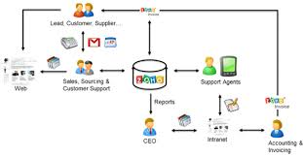

**Result**

**Profit and Loss**

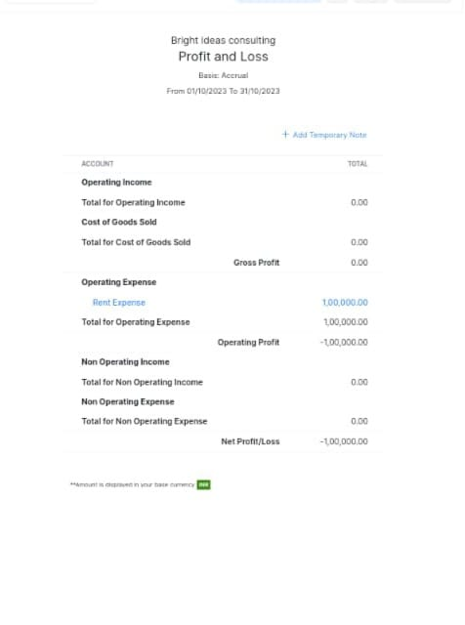

**Balance Sheet**

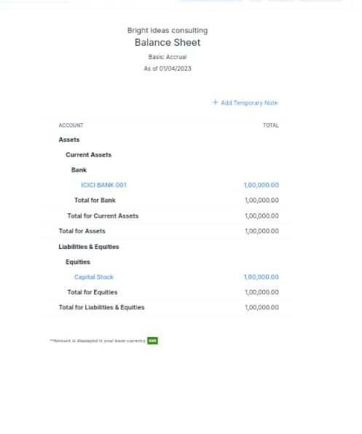

**EMPATHY MAP:**

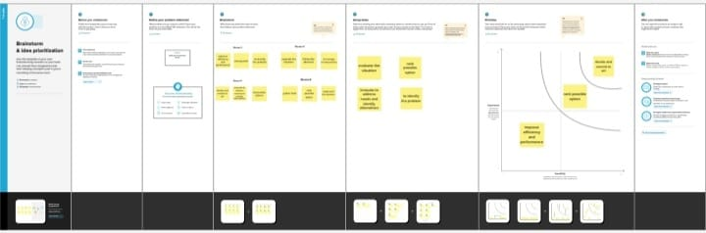

**BRAIN STROMING:**

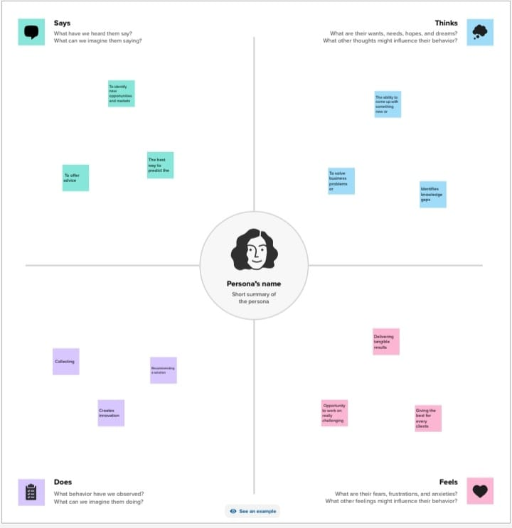

**Payment reminder**

During out testing found that bright consulting idea makes its easy and convenient to automate payment email reminder and create multiple message that go out at different types times. for example you can create a payment reminder email and send it a week before the invoice due send a second email on the due date and send a third email a week after the due date if you haven’t yet received payment.

**Conclusion:**

* Bright ideas are committed to helping you realize your event or business vision with their customized partnership option.